Test Case: tc002_SPX_Dev5_Crear_Requisicion_Spot_Con_FAD_Tipo_Cobro_CC
Step 1 - Enter username and password and click to button Enter : Credentials Entered
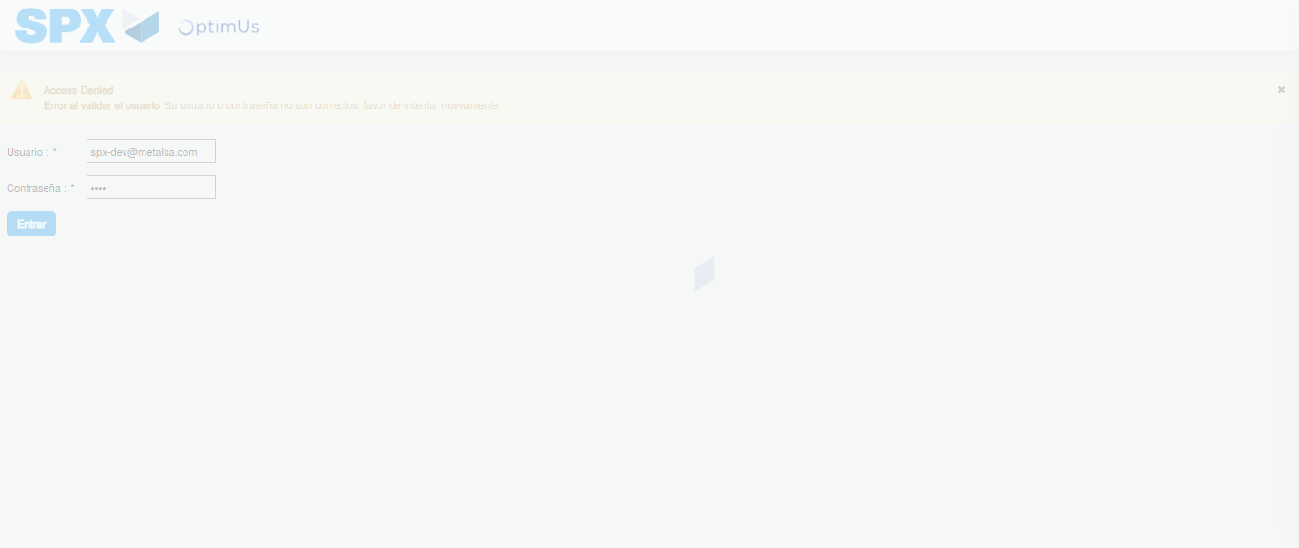Image file-name: QC_Testing-tc002_SPX_Dev5_Crear_Requisicion_Spot_Con_FAD_Tipo_Cobro_CC-1790178276711

Step 2 - Select to UEN and Access to Spot Buy Requisitions : UEN Correctly selected and Correct access
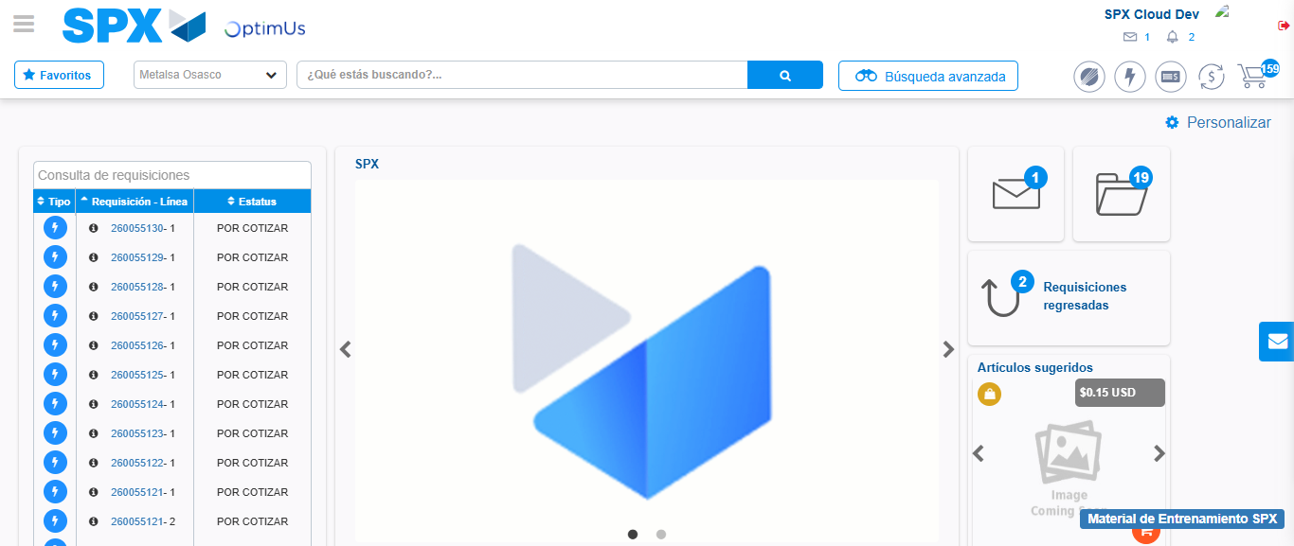Image file-name: QC_Testing-tc002_SPX_Dev5_Crear_Requisicion_Spot_Con_FAD_Tipo_Cobro_CC-1790178308339

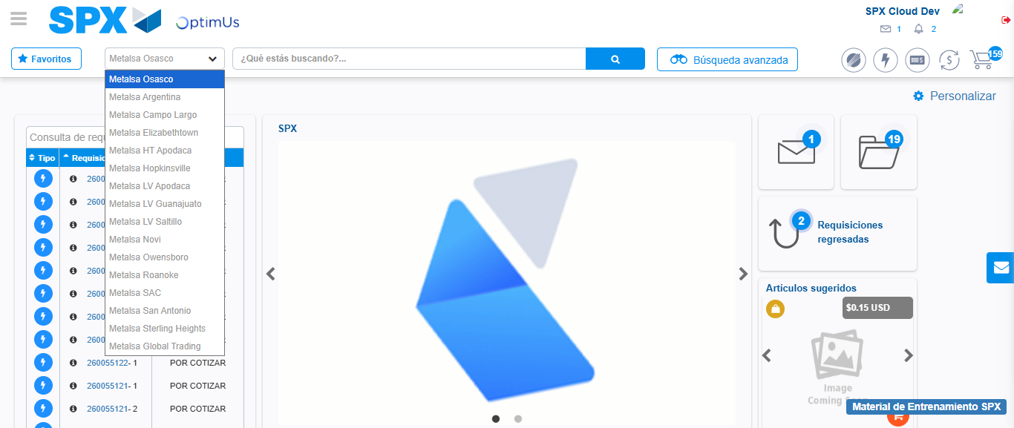Image file-name: QC_Testing-tc002_SPX_Dev5_Crear_Requisicion_Spot_Con_FAD_Tipo_Cobro_CC-1790178308872

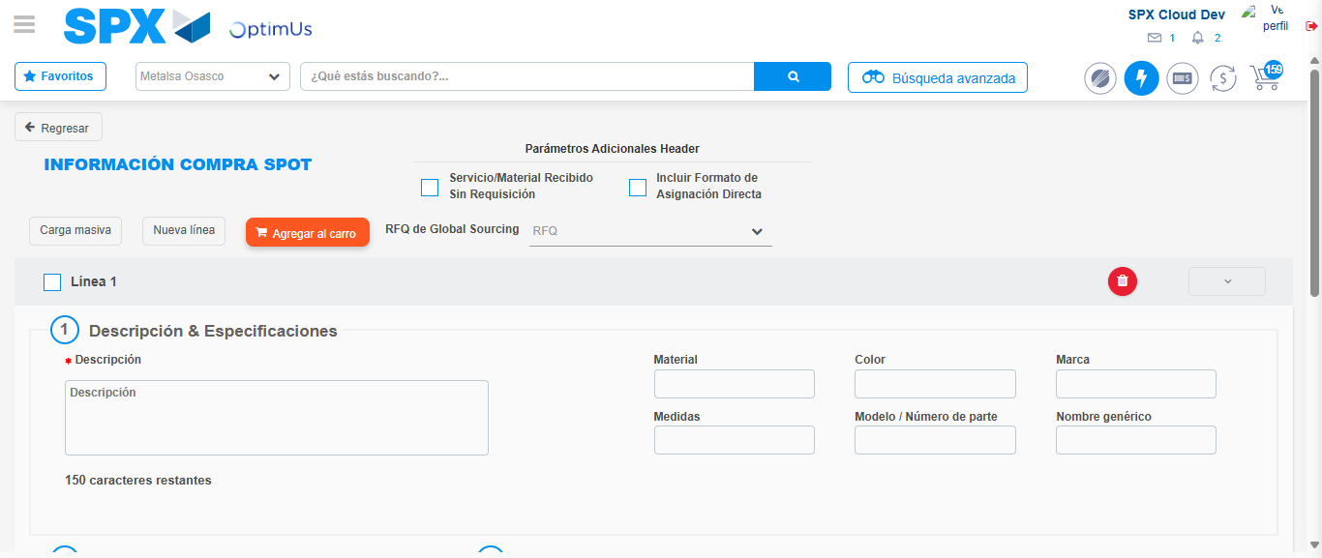Image file-name: QC_Testing-tc002_SPX_Dev5_Crear_Requisicion_Spot_Con_FAD_Tipo_Cobro_CC-1790178314210

Step 3 - Add FAD to Requisition: FAD Successfully Added
Image file-name: QC_Testing-tc002_SPX_Dev5_Crear_Requisicion_Spot_Con_FAD_Tipo_Cobro_CC-1790178314426

Image file-name: QC_Testing-tc002_SPX_Dev5_Crear_Requisicion_Spot_Con_FAD_Tipo_Cobro_CC-1790178314603

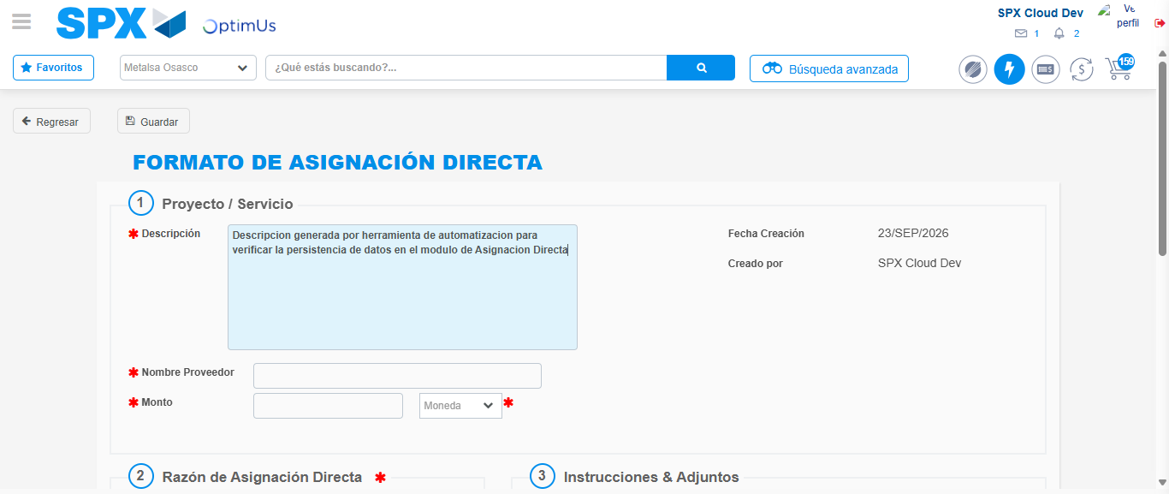Image file-name: QC_Testing-tc002_SPX_Dev5_Crear_Requisicion_Spot_Con_FAD_Tipo_Cobro_CC-1790178317310

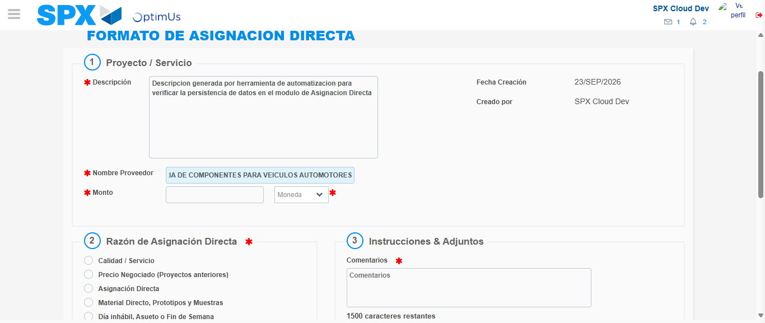Image file-name: QC_Testing-tc002_SPX_Dev5_Crear_Requisicion_Spot_Con_FAD_Tipo_Cobro_CC-1790178325929

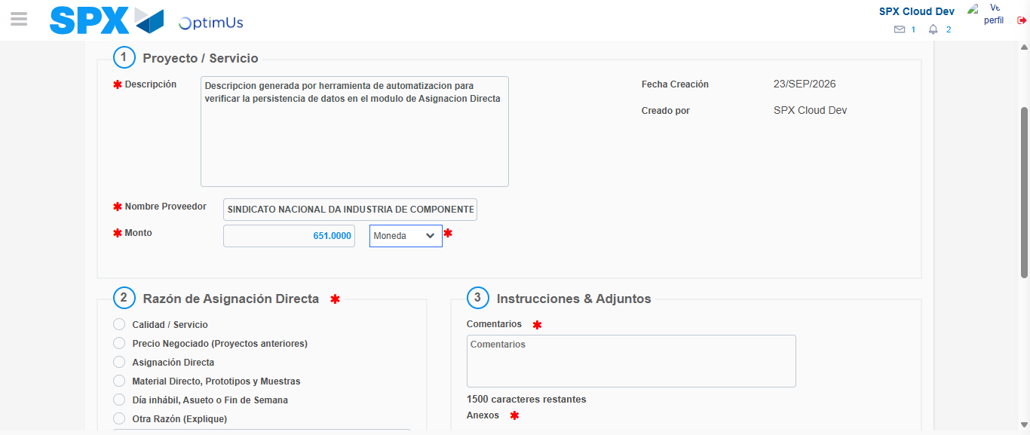Image file-name: QC_Testing-tc002_SPX_Dev5_Crear_Requisicion_Spot_Con_FAD_Tipo_Cobro_CC-1790178326301

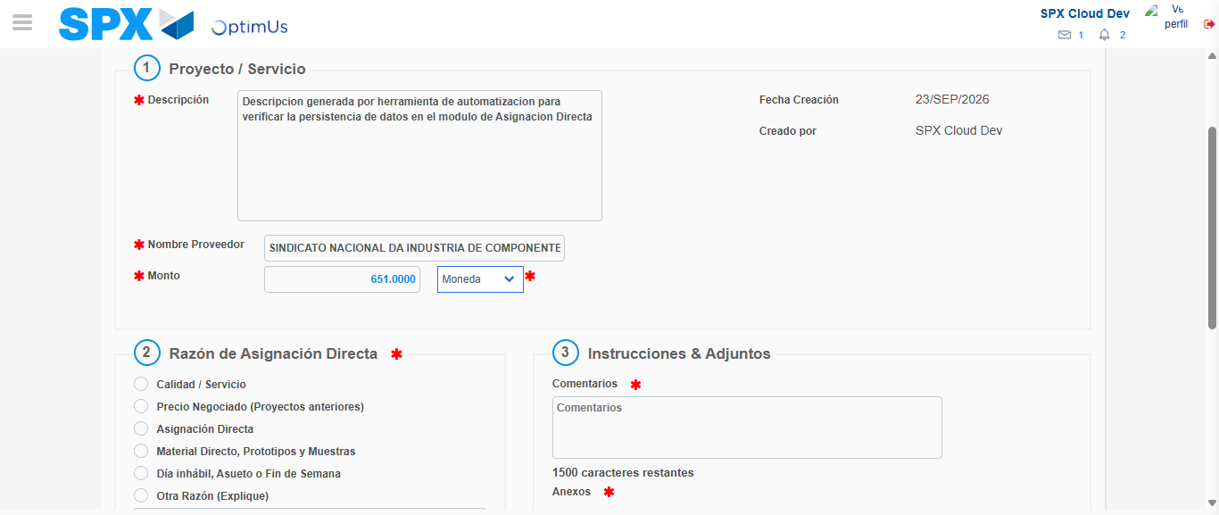Image file-name: QC_Testing-tc002_SPX_Dev5_Crear_Requisicion_Spot_Con_FAD_Tipo_Cobro_CC-1790178326483

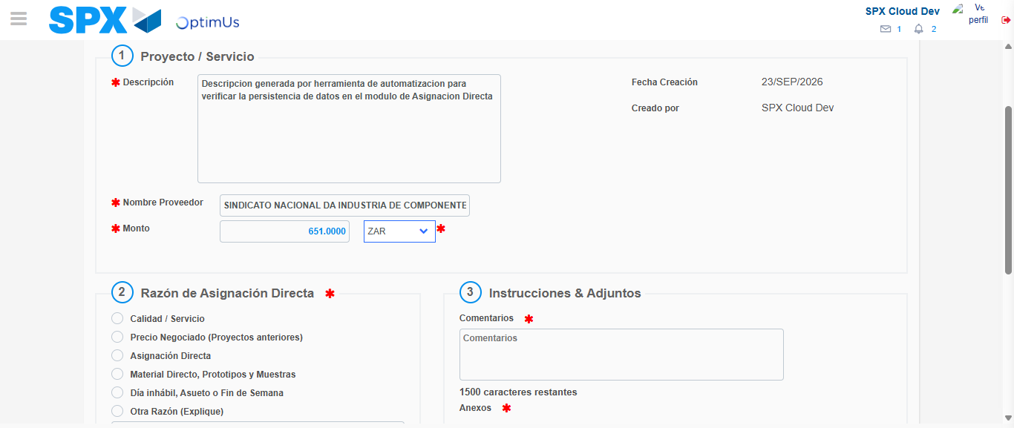Image file-name: QC_Testing-tc002_SPX_Dev5_Crear_Requisicion_Spot_Con_FAD_Tipo_Cobro_CC-1790178326796

Image file-name: QC_Testing-tc002_SPX_Dev5_Crear_Requisicion_Spot_Con_FAD_Tipo_Cobro_CC-1790178326988

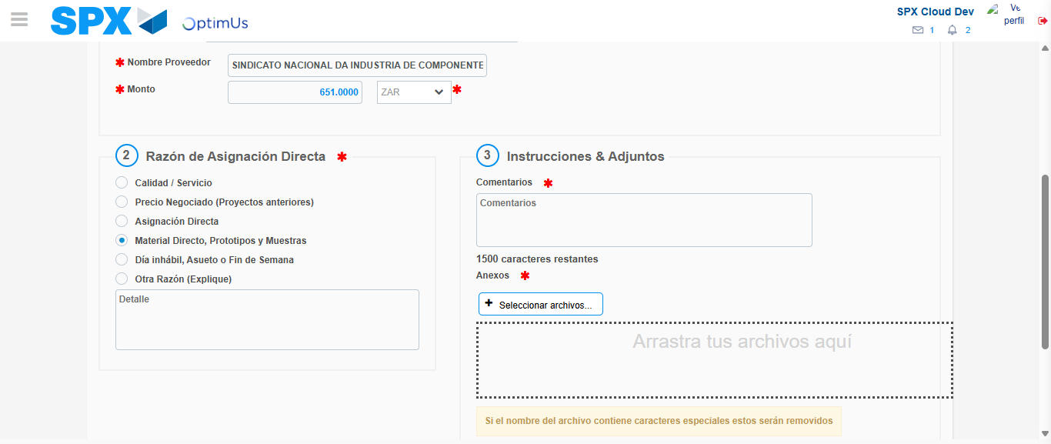Image file-name: QC_Testing-tc002_SPX_Dev5_Crear_Requisicion_Spot_Con_FAD_Tipo_Cobro_CC-1790178327772

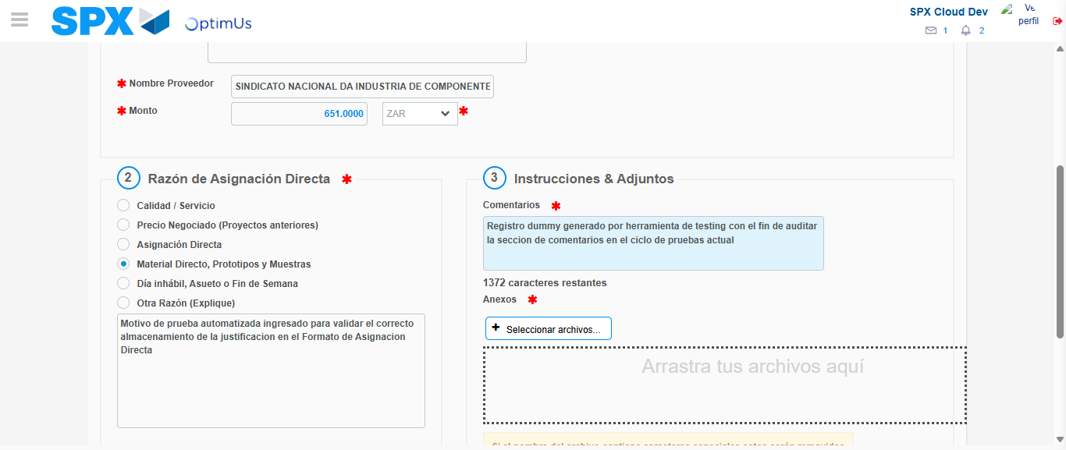Image file-name: QC_Testing-tc002_SPX_Dev5_Crear_Requisicion_Spot_Con_FAD_Tipo_Cobro_CC-1790178338721

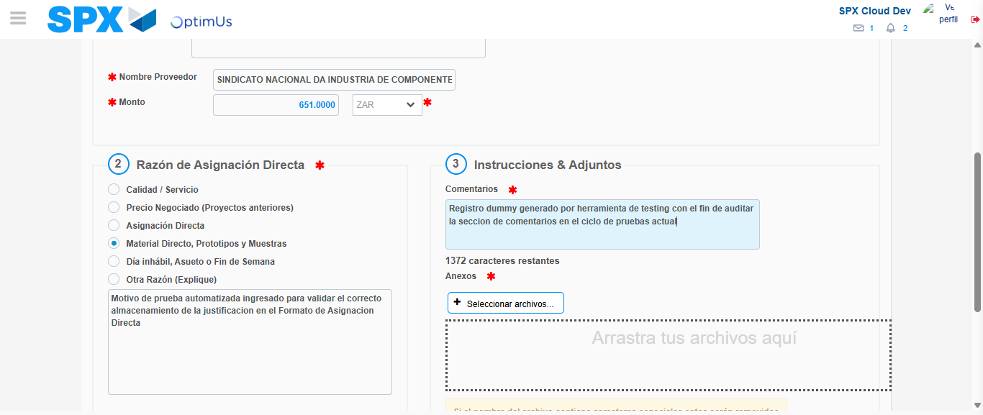Image file-name: QC_Testing-tc002_SPX_Dev5_Crear_Requisicion_Spot_Con_FAD_Tipo_Cobro_CC-1790178339318

Step 4 - Data Capture Spot Buy Requisition: Data captured correctly
Image file-name: QC_Testing-tc002_SPX_Dev5_Crear_Requisicion_Spot_Con_FAD_Tipo_Cobro_CC-1790178314426

Image file-name: QC_Testing-tc002_SPX_Dev5_Crear_Requisicion_Spot_Con_FAD_Tipo_Cobro_CC-1790178314603

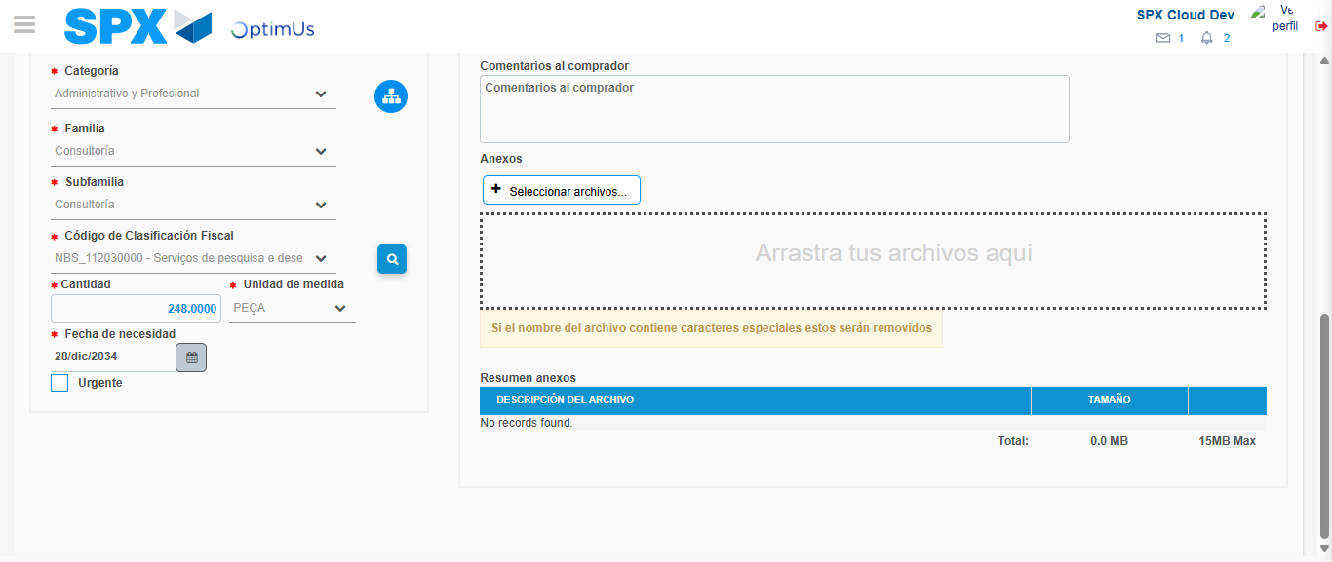Image file-name: QC_Testing-tc002_SPX_Dev5_Crear_Requisicion_Spot_Con_FAD_Tipo_Cobro_CC-1790178356455

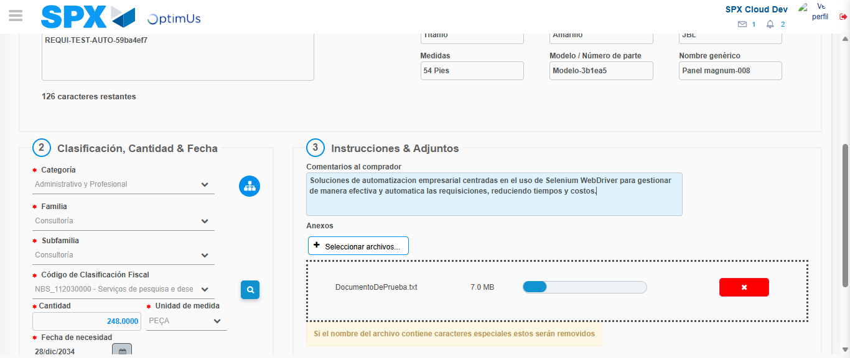Image file-name: QC_Testing-tc002_SPX_Dev5_Crear_Requisicion_Spot_Con_FAD_Tipo_Cobro_CC-1790178357156

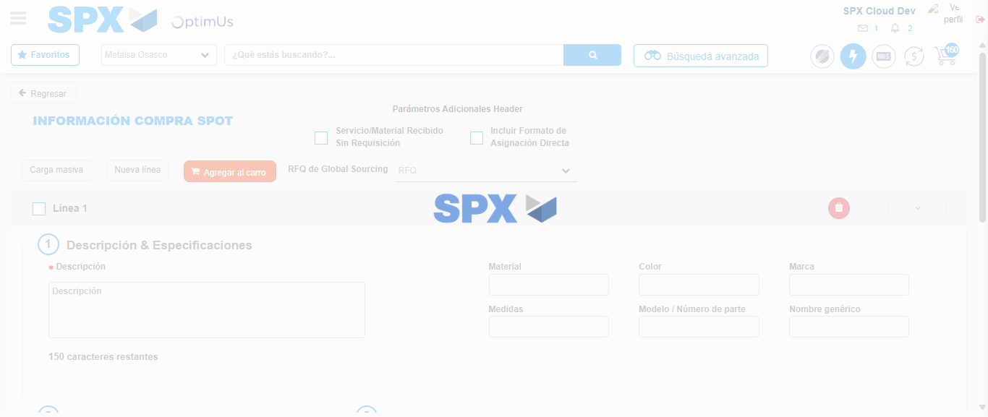Image file-name: QC_Testing-tc002_SPX_Dev5_Crear_Requisicion_Spot_Con_FAD_Tipo_Cobro_CC-1790178389086

Step 8 - Return to Main Page SPX : Return to Main Page SPX
Image file-name: QC_Testing-tc002_SPX_Dev5_Crear_Requisicion_Spot_Con_FAD_Tipo_Cobro_CC-1790178308339

Image file-name: QC_Testing-tc002_SPX_Dev5_Crear_Requisicion_Spot_Con_FAD_Tipo_Cobro_CC-1790178308872

Image file-name: QC_Testing-tc002_SPX_Dev5_Crear_Requisicion_Spot_Con_FAD_Tipo_Cobro_CC-1790178314210

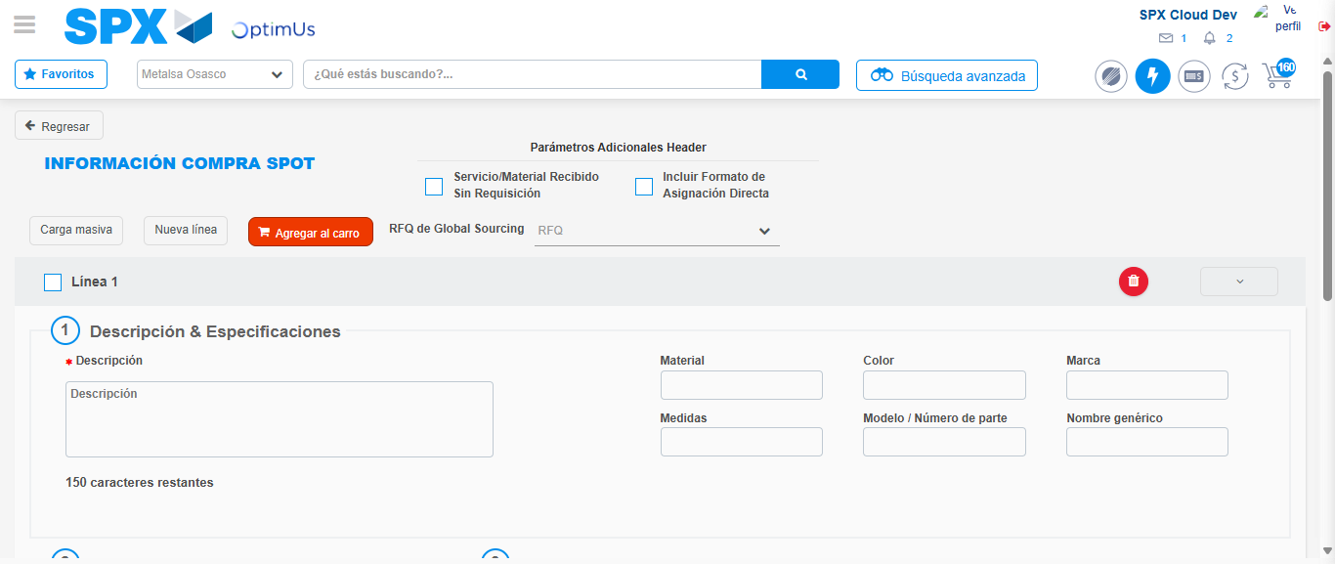Image file-name: QC_Testing-tc002_SPX_Dev5_Crear_Requisicion_Spot_Con_FAD_Tipo_Cobro_CC-1790178391322

Image file-name: QC_Testing-tc002_SPX_Dev5_Crear_Requisicion_Spot_Con_FAD_Tipo_Cobro_CC-1790178391477

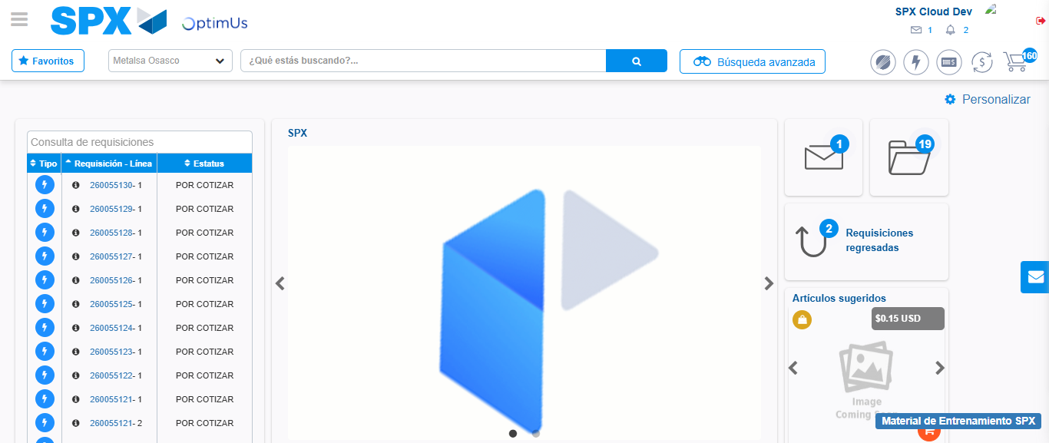Image file-name: QC_Testing-tc002_SPX_Dev5_Crear_Requisicion_Spot_Con_FAD_Tipo_Cobro_CC-1790178412727

Step 9 - Log Out : Log Out SPX
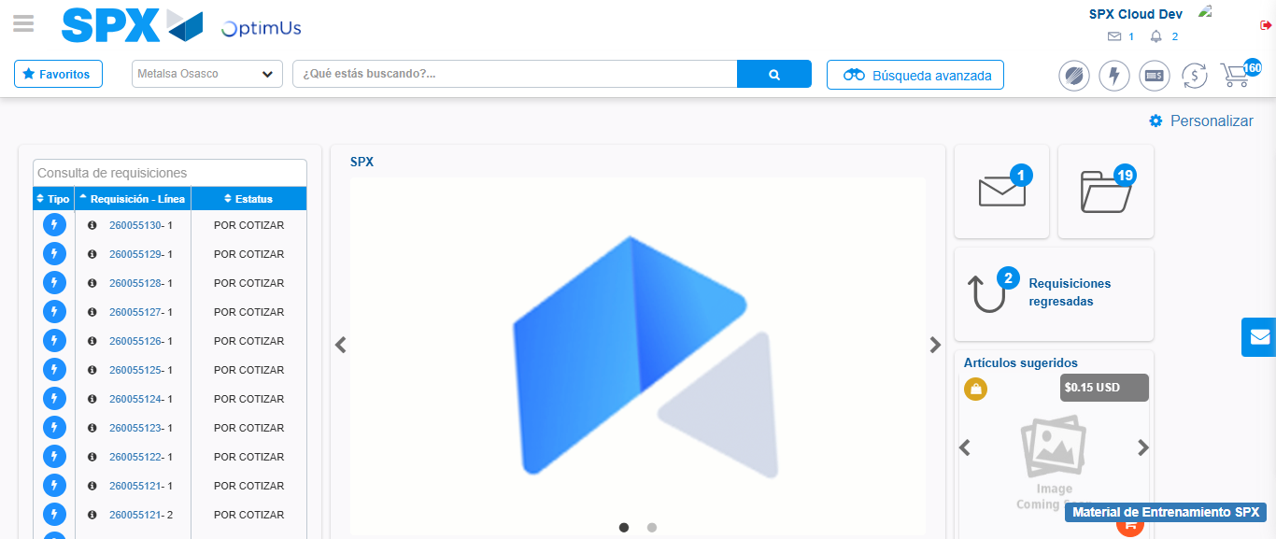Image file-name: QC_Testing-tc002_SPX_Dev5_Crear_Requisicion_Spot_Con_FAD_Tipo_Cobro_CC-1790178412999

